Adaptive Interview Evaluation Using LLM and Retrieval-Augmented Generation

Ganesh E
Department of Computer and Communicaiton Engineering
Rajalakshmi Institute of Technology
Chennai, India
eganesh90@gmail.com
Deepanshu Mohanty
Department of Computer and Communicaiton Engineering
Rajalakshmi Institute of Technology
Chennai, India
deepanshumohanty@gmail.com
V.Dakshin Aditya
Department of Computer and Communicaiton Engineering
Rajalakshmi Institute of Technology
Chennai, India
vdakshinaditya@gmail.com

Karthick Raja M K
Department of Computer and Communication Engineering
Rajalakshmi Institute of Technology
Chennai, India
mkkarthickraja07@gmail.com

Abstract— Candidates who prepare for their interviews experience increased confidence which leads to better chances of getting hired. The current mock interview systems depend on fixed question banks and rule-based evaluation methods and cloud systems which create security problems and increase operational expenses while preventing customized assessments. The paper presents an artificial intelligence interview simulation system which uses local Large Language Models (LLMs) and a Retrieval-Augmented Generation (RAG) framework to deliver safe and customized interview training. The system uses PDF and DOCX resumes which users submit to extract relevant skills and competencies through spaCy and a custom skill dictionary. The locally installed LLMs create domain-specific interview questions according to the extracted profiles which are specific to each candidate. The RAG framework which uses FAISS and MiniLM embeddings enables contextual grounding while enhancing factual consistency throughout question creation and response assessment. The system evaluates user responses through a grading system which produces consistent results that maintain fairness during the assessment process. The system functions through Ollama-based LLMs which operate entirely on local servers to provide data privacy and cut operational expenses and permit offline access. The intelligent interview training platform shows its effectiveness through the system which creates adaptive questions while delivering accurate assessments and tracking user progress through different sessions and enables users to experience instant system performance.
Keywords – Large Language Model, RAG, Resume, Interview training.

Introduction

The process of preparing for interviews leads to essential professional growth because it determines how well candidates can communicate which strengthens their chances of being hired. The use of standard interview procedures which include fixed question banks and peer-based mock interviews along with rule-based evaluations provides insufficient customization options. These methods do not match the particular characteristics of different candidates. The methods depend on standard templates and common evaluation methods which prevent actual performance assessment from being conducted and valuable performance evaluations from being obtained. The process gives candidates basic directions which only provide general information about their strengths and weaknesses without showing their unique learning requirements.

Intelligent interview simulation systems received their first development through recent AI and natural language processing research breakthroughs. LLM have the ability to interpret context which enables them to produce relevant text while assessing open-ended answers. The interview preparation process is enhanced by these models through domain-specific question generation and human-like evaluation of candidate responses, which enables them to assess candidates with greater precision. The study demonstrates that AI-driven platforms provide better results than traditional methods for interview preparation.
The current AI systems require cloud infrastructure for most of their functions. The system needs users to maintain internet connection while it stores protected information on third-party servers which creates multiple data protection challenges, security threats, increased operational expenses and limited system access. Educational institutions and resource-constrained environments experience major difficulties because they lack dependable internet access and paid cloud services. The current systems face challenges because they cannot use resume-based personalization methods to match users effectively. A resume shows all the qualifications and work history details of a candidate. Many platforms do not use extract resume data effectively, while they conduct search through fundamental keyword matching techniques. This method produces standard interview questions which do not match the particular qualifications of candidates. The traditional rule-based grading systems cannot assess open-ended answers while standard natural language processing methods fail to capture vital contextual and semantic elements of the text.
This paper suggests an interview simulation and candidate evaluation framework driven by AI for tackling these limitations. LLMs and RAG combine to build an interview training system which protects user data and offers customized training options. The system starts its process by scanning resumes in PDF or DOCX format to identify necessary skills and competencies through the use of spaCy and a tailored skill dictionary. The system generates interview questions based on skills which have been extracted through a locally operating LLM. The system uses RAG with FAISS and MiniLM embeddings to obtain necessary reference materials which help maintain factual accuracy and contextual relevance in both question generation and response evaluation.
The system implementation uses complete local deployment of artificial intelligence components through Ollama-based LLMs which provide offline functionality without needing cloud services. The system design protects data privacy while decreasing operational expenses. The evaluation process uses a structured rubric to achieve consistent assessment of candidate responses without bias. The performance analytics module creates session-based insights which help candidates discover their skill deficiencies and monitor their progress throughout the assessment period.
The proposed AI-based interview simulator system links traditional mock interview systems with contemporary intelligent tutoring systems. The system delivers complete solution through its combination of resume-based personalized training on key skills of candidate. The model evaluates candidate response to questions and provides feedback on answers from candidate. In addition, the model can also be used to evaluate technical knowledge of candidates from their resumes in real time. AI models can generate technical questions from resumes based on key skills mentioned by candidate. The model can adjust difficulty of questions based on required job role. The model analyzes answers from candidate and probes questions further to evaluate technical competency. The models interview process oversee by human to ensure process is in alignment with job description and eliminate any discriminatory bias.

RELATED WORKS
AI systems developed through Natural Language Processing technology have created intelligent systems which help users prepare for interviews and analyze resumes and perform automated evaluations and deliver customized educational experiences. Recent research has explored various aspects which include Large Language Model LLM assessment resume parsing skill extraction AI question generation and Retrieval Augmented Generation RAG architecture and speech and sentiment analysis and traditional interview evaluation frameworks.
An Interview System Base on Large Language Models with Multi-Agent Interactions was released in 2024. The research develops an interview simulation system which uses Large Language Models together with multi-agent systems to create and improve interview questions. Multiple AI agents use feedback from each other to improve the relevance, clarity and contextual accuracy of questions which they develop together. The study shows that LLM-driven interview systems create realistic and adaptive and high-quality interview experiences which demonstrate how intelligent automation improves personalized and interactive interview preparation environments.[1]
In 2023, a new resume parsing framework was developed. The framework employs BERT for contextual meaning extraction instead of using standard keyword matching methods. The model achieves better extraction results through its understanding of how skills experience and job roles relate to each other. The research demonstrates how deep language representations enable better resume comprehension and validates our spaCy-based skill extraction system. The study demonstrates how contextual embeddings can create customized interview questions for individual users.[2]
Resspar: AI-Driven Resume Parsing and Recruitment System using NLP and Generative AI, 2024: The research presents an artificial intelligence recruitment system which utilizes natural language processing and generative artificial intelligence to extract structured data from resumes and both scanned and unstructured documents. The framework increases system reliability for resume comprehension and data standardization. Our system includes a pipeline which processes resume uploads and performs initial screening to demonstrate how NLP and generative models improve skill extraction and resume-based personalization.[3]
A Large Language Model-Driven MCQ Generator for Personalised Learning 2024 introduces an LLM-based system which generates questions through its implementation of Retrieval-Augmented Generation and advanced prompt engineering methods. The system generates output through knowledge retrieval which guarantees both content accuracy and diverse knowledge results. The system provides direct assistance to our RAG-based question generation framework which shows that LLMs combined with retrieval systems create better context understanding and decrease hallucinations during the generation of interview questions.[4]
Transformer and Large Language Models for Automatic Question Generation: A Systematic Review, 2024: The systematic review examines automatic question generation through its examination of transformer and LLM-based methods which include fine-tuning and zero-shot and few-shot and chain-of-thought prompting techniques. The study demonstrates RAG's ability to enhance both question quality and coherence through its implementation. The research study establishes a solid theoretical base which supports our LLM-based interview question module while it validates our choices of prompt design and retrieval augmentation methods.[5]
A Comparative Analysis of Large Language Models with Retrieval-Augmented Generation based Question Answering System, 2024: The research studies various LLMs which operate through RAG frameworks and shows that retrieval grounding technology boosts their capacity to produce correct and relevant answers with consistent results. The comparative results show that RAG reduces hallucinations and improves contextual understanding. This research demonstrates that our use of FAISS and MiniLM embeddings demonstrates RAG serves as a fundamental requirement for dependable knowledge-based interview question creation and assessment.[6]
A study developed a system that analyzes resumes and provides job recommendations through Machine Learning techniques which will be implemented in 2024. The system uses spaCy together with PDF processing tools to extract candidate skills and experiences from resumes. The system demonstrates its ability to understand resumes and deliver personalized services to users. The method uses spaCy-based skill extraction to confirm our lightweight natural language processing system which enables resume-based user personalization and precise candidate assessment in interview preparation tools.[7]
The 2023 research document titled Retrieval-Augmented Generation for Large Language Models presents a complete study of RAG architectural designs which include basic and complex and modular frameworks. The system provides our FAISS-based RAG implementation with theoretical support while our choice to use retrieval systems for interview question creation and assessment purposes we develop through our architectural design.[8]
The 2024 research study Grade Like a Human: Rethinking Automated Assessment with Large Language Models proposes a grading system which uses LLM technology and structured rubrics to deliver assessment results that match human evaluation standards. The system demonstrates high alignment between its automated assessment results and human evaluation while it enhances assessment fairness and maintains consistent results. The research study provides evidence which supports our five-criteria grading system while it proves that LLMs can effectively assess open-ended interview answers with dependable accuracy.[9]
A LLM-Powered Automatic Grading Framework with Human-Level Guidelines Optimization, 2024: This paper presents a multi-agent automatic grading system which uses reflective agents and optimization agents to enhance assessment quality. The system achieves higher accuracy than single-model graders. The evaluation method shows that advanced LLM architectures can enhance the consistency and reliability and robustness of automated interview answer assessment systems.[10]
Retrieval-Augmented Generation study provides a detailed examination of advanced RAG architectures which the authors divide into three different categories: retriever-centric models, generator-centric models, and hybrid models. The solution emphasizes three key performance attributes which include robustness and scalability and consistent output through knowledge-grounded generation. The insights we obtained from our research support our hybrid RAG design while demonstrating that our system operates effectively with FAISS and MiniLM to produce accurate interview content generated through efficient processes.[11]
Agentic Retrieval-Augmented Generation: A Survey on Agentic RAG, 2025: The researchers investigate RAG systems which use autonomous agents to handle all three components of their system: retrieval, reasoning, and generation. The research demonstrates that response quality increases when planning and reflection are used. The study uses a basic RAG system but shows how researchers can implement agentic behavior to create more flexible and tailored interview practice systems.[12]
Graph Retrieval-Augmented Generation: A Survey, 2024: The study evaluates GraphRAG, which demonstrates enhanced retrieval accuracy and improved semantic understanding through its use of structured graph-based knowledge systems. The system demonstrates its capability to manage intricate connections between different concepts. The project demonstrates its value through future system development which will implement interview knowledge base organization using skill hierarchies and dependency graph systems to improve information retrieval.[13]
Automatic Assessment of Text-Based Responses in Post-Secondary Education: A Systematic Review, 2024: The study reviews AI-based automated text assessment methods and finds that rubric-guided LLM systems produce the most consistent and understandable results. The study provides strong support for our LLM-based answer evaluation framework while demonstrating that structured multi-criteria grading enables fair assessment of interview responses.[14]
Can Large Language Models Meet the Challenge of Generating School-Level Questions?, 2025: The research tests LLMs for their ability to generate questions through four evaluation metrics which include relevance and grammaticality and usefulness and answerability. The study demonstrates that LLMs generate high-quality questions when researchers provide them with suitable restrictions and necessary background information. The system verifies our interview question creation tool which uses LLM technology and it confirms the effectiveness of our assessment metrics.[15]
The existing commercial interview preparation platforms which extend beyond academic research utilize basic NLP methods together with their cloud-based AI systems. The systems provide automation and scalability features but their user interface lacks customized options and needs assessment standards and external data handling creates major security risks. Most of these systems do not provide users with in-depth performance tracking tools which enable them to monitor their development throughout the entire duration of their usage. The proposed AI interview simulator unites the advantages from multiple research fields while solving their existing weaknesses. The system combines two elements which are resume-driven personalisation with advanced skill extraction methods and LLM-based context-aware question generation and RAG-based response grounding which uses FAISS and MiniLM embeddings. The system uses a five-criteria grading rubric which contains predefined standards to achieve fair and uniform assessment of candidate responses. The system functions as an entirely local solution which uses Ollama-powered LLMs to achieve complete data protection and decreased cloud resource needs and cost savings and offline capabilities.
The research work of previous studies examined single elements of resume parsing and question generation and answer evaluation and adaptive learning. The proposed system bridges this gap by integrating intelligent resume analysis adaptive personalised questioning RAG-enhanced content generation structured multi-criteria evaluation and performance analytics within a single cohesive architecture. The system uses a complete solution that functions as an efficient system for preparing interviews with artificial intelligence technologies.

METHODOLOGY
The proposed AI-powered interview simulator functions as a complete intelligent system which handles all aspects of interview preparation. The system performs three primary functions which include resume analysis, performance evaluation and progress tracking. The system combines AI and natural language processing components which include resume parsing, skill extraction, local LLM-based question generation, Retrieval-Augmented Generation (RAG) and structured answer grading and session-based performance analysis. The system architecture enables personalized user experiences through its ability to function offline while protecting user data and preserving their individual settings.

System Architecture Overview
The system operates through a modular pipeline design which includes six core components that work together to process data: Resume Upload and Preprocessing, Skill Extraction and Profiling, Knowledge Retrieval using RAG, Question Generation using Local LLM, Answer Evaluation and Grading, Performance Analytics and Progress Tracking. The modules operate as separate units which use a centralized FastAPI backend system to maintain their operational capacity and system maintenance needs. The frontend system connects to the backend system through RESTful APIs which enable users to interact seamlessly while the system handles their requests in real time. Figure 1 shows overview of AI interview simulator.

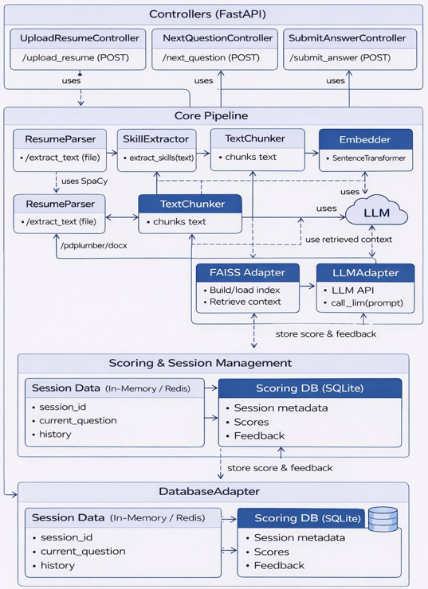
Figure 1: Overview of AI interview simulator.

Resume Upload and Preprocessing
The system accepts resumes in PDF and DOCX formats, which are the most common formats used in real-world job applications. The document undergoes preprocessing after upload to transform it into structured plain text format. PDF files use libraries such as pdfplumber and PyMuPDF while DOCX files use python-docx for parsing text from files. The text cleaning process removes all headers and footers together with special characters and formatting noise, while it transforms all text to lowercase through punctuation and whitespace normalization. The application uses heuristic rules and keyword matching to divide resume text into sections which contain Skills, Education, Projects, Experience and Certifications. The preprocessing stage provides structured data through information extraction and maintains complete data integrity for subsequent natural language processing activities.

Skill Extraction and Profiling
The system uses skill extraction to achieve resume-based personalisation which depends on spaCy-Named Entity Recognition and a specialized skill dictionary that contains technical and professional domain expertise. The spaCy NLP pipeline uses four components including tokenization, part-of-speech (POS) tagging, dependency parsing and Named Entity Recognition. The custom skill dictionary contains domain-specific technical skills such as Python, FastAPI, Machine Learning, SQL, and NLP, as well as soft skills like communication, leadership, and teamwork. The system supports multi-word expressions which include deep learning and data structures and cloud computing. The matching system uses exact matching to achieve precise skill detection and fuzzy matching through cosine similarity to identify different forms and short forms of terms. The system categorizes extracted skills into three groups: technical skills, analytical skills and soft skills, while it builds a candidate profile vector to demonstrate the candidate’s skills. The module achieved high skill extraction accuracy, demonstrating its effectiveness in identifying relevant competencies from resumes. The system successfully extracted skills from resumes because it reached its peak performance level.

Retrieval-Augmented Generation (RAG) Framework
The system uses a RAG architecture to achieve better factual accuracy and relevant results. MiniLM transforms resume skills and interview topics into dense vector embeddings. Facebook AI Similarity Search (FAISS) in RAG system stores and retrieves data to enable fast nearest-neighbour searches on extensive datasets. The knowledge base contains curated interview questions technical definitions and domain references which the system arranges according to job roles and skill categories. The system retrieves top-k relevant documents for each skill or topic during the retrieval process which it uses as context to provide data to the LLM. This approach improves question relevance because it ensures that generated responses use domain-specific knowledge instead of relying on random generation.

Question Generation Using Local LLM
The question generation module uses a locally installed LLM that operates through Ollama to create interview questions which extract candidate skills from resumes using prompt engineering. The module generates interview questions across multiple difficulty levels and interview domains, supported by RAG-based context retrieval to ensure relevance and consistency. The approach removes all requirements for cloud API usage which results in complete data protection and permits system operation without internet access. The module generates multiple question types which include conceptual questions, scenario-based questions, resume-project-based questions and behavioural interview questions, while achieving an average inference time of 2 seconds per question and maintains strong contextual relevance and diverse question types.

Performance Analytics and Progress Tracking
The complete user interaction workflow which the analytics module operates within the designated workflow path is shown in figure 2. Candidate uploads the resume through the web interface and then the system starts chunking and embedding process which it uses to extract essential contextual data from the vector database while it creates interview questions through its LLM service. The LLM adapter evaluates user answers as they submit them because RAG supports its knowledge-based assessment process which results in accurate evaluations. The evaluation results including scores and qualitative feedback get transferred through the database adapter which stores them in the scoring database (SQLite). This system provides session-based user performance tracking because it keeps every interaction for future examination. The system uses stored data to create summaries which the system presents to users through the web interface thus completing the feedback loop. The analytics module tracks evaluation results and feedback which enables session-based progress monitoring to show performance changes between different testing periods. The assessment process uses this organized pipeline to create transparent and consistent assessment procedures which deliver dependable results while creating personalized feedback that shows interview preparation progress.
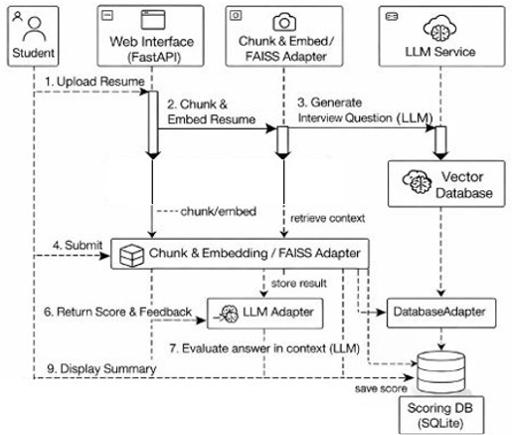Figure 2: User interface workflow

Privacy and Local Deployment
The system enables complete local deployment through its methodology, which allows LLMs to operate on local machines using Ollama, while protecting user data by preventing any transmission of resume or user data to remote servers, which enables offline functionality. The system provides educational institutions with better operational efficiency and increased accessibility because it delivers cost savings and enhanced protection of sensitive information. The system enables unified assessment of candidates through its capability to analyze resumes and evaluate their performance and monitor their progress. The system includes multiple AI and NLP components which operate through resume parsing and skill extraction and local LLM-based question generation and Retrieval-Augmented Generation (RAG) and structured answer grading and analytics-driven feedback. The system architecture provides users with personalized experiences because it allows them to use the system offline while maintaining their private information and customized settings.

results
The system's performance evaluate through six different measurement metrics which include resume parsing, skill extraction accuracy, question relevance, answer evaluation consistency, system responsiveness and overall candidate performance improvement. The pilot test process used different types of resumes together with various interview scenarios to test the system's ability to function effectively in real-world situations.

Experimental Setup
Experiment was conducted with a dataset that contained Ten resumes from students and entry-level professionals who worked in technical fields such as Computer Science and Information Technology and Data Science and Artificial Intelligence. The resumes were submitted in PDF and DOCX file formats which contained different structural elements and formatting styles and levels of difficulty. Each resume underwent preprocessing, skill extraction, question generation, answer evaluation and performance tracking. The local LLM was executed using Ollama while FAISS and MiniLM embeddings supported the RAG module. The system performance evaluation tests were run on a standard workstation because the system requires no advanced GPU capabilities. The evaluation metrics measured three components which included skill extraction accuracy and question evaluation of their relevance and quality and answer evaluation consistency together with the system response time and user performance advancement.

Skill Extraction Performance
Figure 3 shows classification accuracy for three language models through the use of Precision, Recall, and F1-score performance measurements.
$Precision = \frac{TP}{\left(TP + FP\right)}$ (1)
$Recall = \frac{TP}{\left(TP + FN\right)}$ (2)
$F1 = 2 ×\frac{\left(Precision × Recall\right)}{\left(Precision + Recall\right)}$ (3)
Llama3:8B achieved its best results through its Precision measurement of 60.67% and its Recall measurement of 73.82% and its F1-score measurement of 66.60% which showed its strong capacity to find relevant skills while reducing incorrect predictions. Gemma2:2B achieves its testing results through its Precision measurement of 50.57% and its Recall measurement of 71.25% and its F1-score measurement of 59.04% which indicates that the system detects results accurately at a level of prediction certainty that falls between high and low. Phi3:mini shows comparatively lower performance across all metrics, with Precision of 41.67%, Recall of 51.11%, and F1-score of 45.82%. The results demonstrate that models with higher capacity perform better in multi-category skill detection tasks which results in their increased effectiveness for automated resume ranking and AI-based candidate evaluation systems.
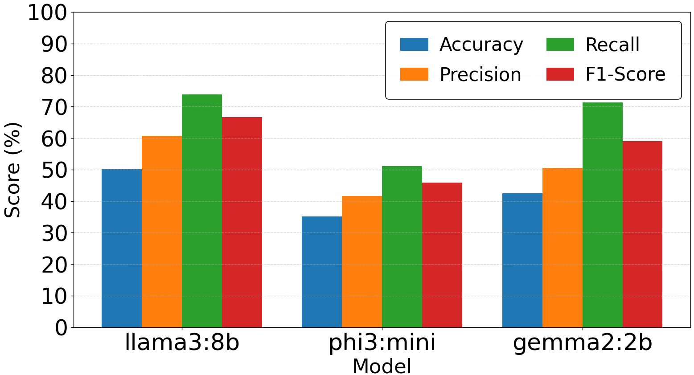
Figure 3: Comparative analysis of models classification accuracy

Question Generation Quality
Figure 4 shows how three lightweight language models produce different text generation results. The results evaluate through BLEU and ROUGE-L metrics. BLEU calculates the n-grams of words in the generated text compared to human text. ROUGE-L compares word sequences for human and machine generated text through n-grams. The Llama3:8B model achieves the highest performance with a BLEU score of 0.1391 and ROUGE-L score of 0.2891, indicating stronger semantic and structural similarity with reference outputs. Gemma2:2B demonstrates moderate performance with BLEU at 0.0883 and ROUGE-L at 0.2238, suggesting reliable but slightly reduced generation quality. Phi3:mini records the lowest scores (BLEU: 0.0523, ROUGE-L: 0.1864), indicating comparatively weaker text similarity performance. The results demonstrate that larger parameter models produce better contextual accuracy and structural text consistency because model size directly affects the quality of natural language generation which functions as an evaluation tool for resumes and text-based assessments.
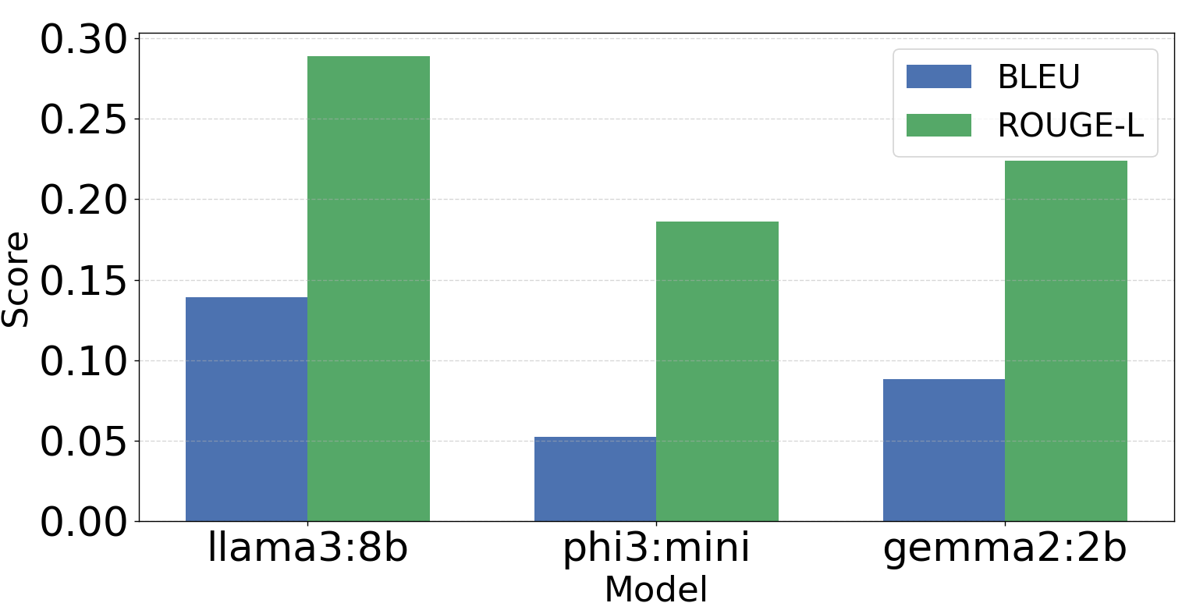
Figure 4: Comparative analysis of models question quality

Consistency Comparative Robustness Evaluation of LLM
Figure 5 evaluates the three lightweight language models by using Macro F1 and Micro F1 scoring systems to assess their performance. LLaMA3:8B achieves the highest Macro F1 score (0.65) which demonstrates its ability to perform equally well across all skill categories; however, its Micro F1 score (0.49) shows its ability to predict outcomes more accurately when using class frequency data. Gemma2:2B shows consistent performance through its Macro F1 score of 0.53 and Micro F1 score of 0.46 which demonstrates its ability to classify at slightly lower levels than LLaMA3:8B. Phi3:mini records the lowest Macro F1 score (0.32) which shows its poor ability to classify between different classes that appear with equal frequency; however, its Micro F1 score of 0.38 shows better performance in identifying main skill categories. The results demonstrate that larger models achieve better balanced performance across multiple skill areas whereas smaller models show improved performance when class distributions are not equal which establishes a relationship between model size and system performance.
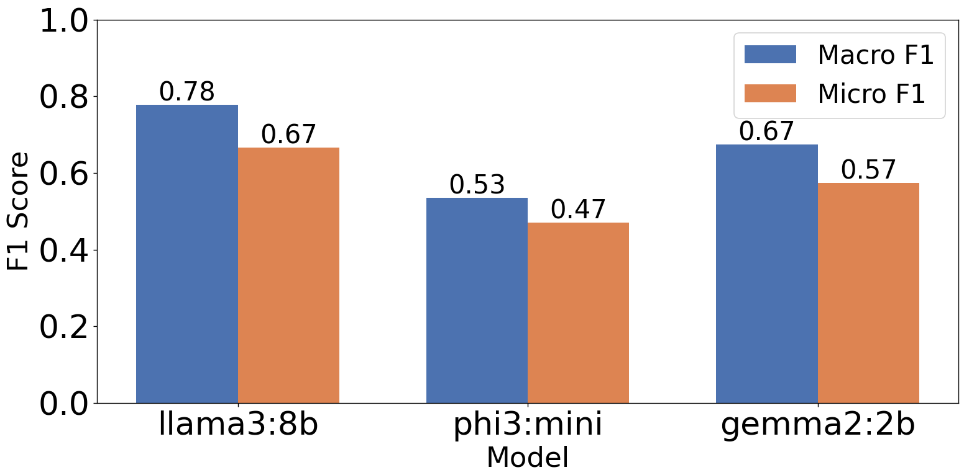
Figure 5: Model performance comparison by Macro, Micro F1 score.

Skill Extraction Coverage Analysis Across LLM’s
The evaluation of all resumes conducts through three lightweight language models. Figure 6 shows the average skill detection result across five different skill categories. LLaMA3:8B demonstrates the most comprehensive skill extraction capability with high success rates in identifying Frameworks/Libraries (3.0) and Programming Languages (2.0) together with moderate success rates in detecting Tools/DevOps (1.67) and Soft Skills (1.33). The system successfully detects both technical abilities and non-technical abilities. Phi3:mini exhibits selective extraction behavior, achieving strong performance only in the Frameworks/Libraries category (3.0) while showing substantially lower detection across other categories especially Soft Skills and Programming Languages (0.33). The system shows restricted capacity to generalize beyond its specialized technical domains. Gemma2:2B shows balanced performance in core technical categories with consistent detection of Programming Languages (2.33) and Frameworks/Libraries (2.33). The system does not successfully capture Soft Skills. Gemma2:2B lacks ability to identify non-technical skills. The results demonstrate that larger models provide superior skill detection capabilities for multiple categories while smaller models restrict their detection abilities to technical fields which results in reduced capacity to identify both skills and their various types.

Scoring Consistency Evaluation Between Human and AI-Based Interview Assessment Systems
The performance of LLM model was scored by HR across five evaluation sessions. Comparison was done for local LLM solution that uses RAG, Phi3:mimi and a cloud-based LLM. The proposed local LLM-RAG shows better performance in identifying skills from resume and provides context aware questions related to skills and projects. The questionnaire from LLM-RAG evaluate by HR with a mean score between 8.0 and 8.4 throughout all testing sessions which demonstrates high reliability with low score variability. The cloud-based LLM and Phi3: mini has less mean score. The models showed less stability, and consistency in providing appropriate questions during evaluation.
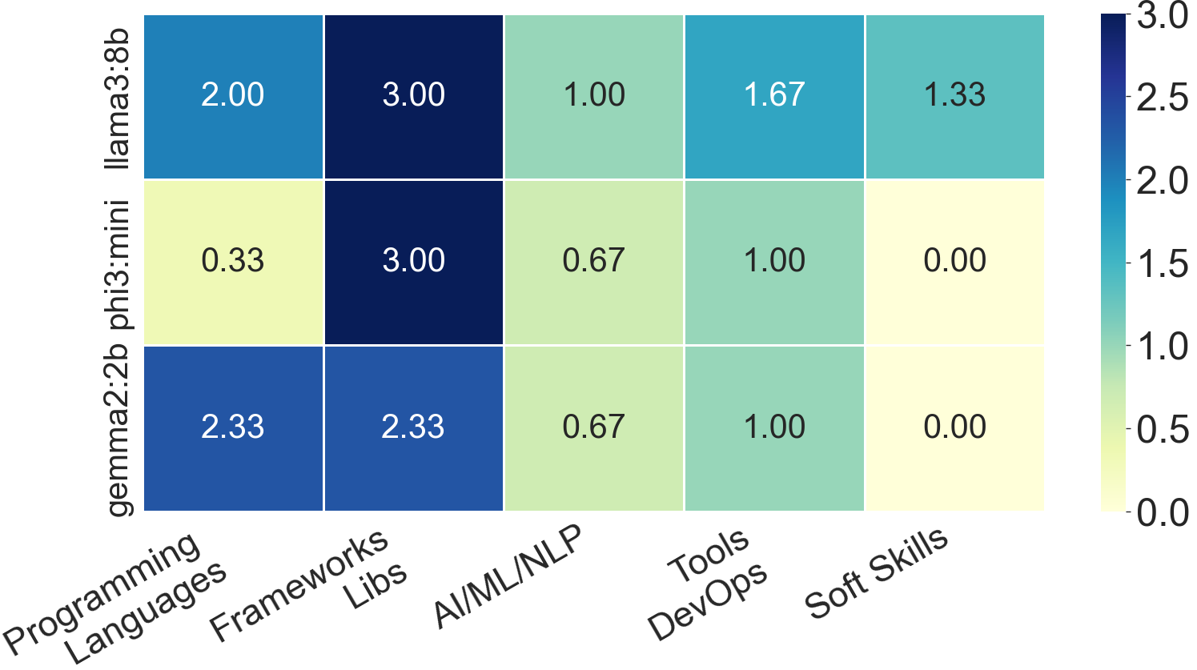
Figure 6: Heatmap of skill detection by different models.

Latency Performance Analysis of AI Resume Processing Based on Input Size
The latency shows a direct relationship to resume size because it uses the total word count of each resume. Smaller resumes with 200 to 250-word length showed average latency of eight seconds including system initialization and processing overhead. The observed inference latency for larger resumes with 480-words showed increased processing time increases at a non-linear rate. The observed trend shows latency remains mostly constant for resumes with word length under 300 words. However, for different resume lengths the latency increases with respect to word length and skill type, technical skill evaluation. The system shows acceptable response times for resumes of different sizes which makes it suitable for automated resume evaluation and interview preparation tasks in real-world scenarios. Figure 7 shows comparison relation between latency and resume with different word counts. The processing time for each resume can be calculate by equation (4).
$y=(0.0038*x)+9.04$ (4)

Answer Evaluation
The evaluation consistency analysis assesses how closely AI-based assessments align with human evaluations and shows strong matching results which prove the assessment system depends on rubric-based evaluations. The rubric-guided evaluation process improves automated grading consistency while it also increases assessment system reliability. Traditional rule-based systems lack the ability to interpret semantic meaning in open-ended responses, whereas the LLM-based evaluator demonstrates human-like reasoning capabilities. The system benefits from local deployment which leads to minimal response latency that enables users to interact with the system in near real time. The proposed system demonstrates improved performance when compared to traditional approaches because it enables more accurate skill extraction and it provides reliable evaluation of candidate responses. The proposed approach enables dynamic RAG-based question generation, context-aware answer evaluation and secure local processing while it allows structured performance monitoring during interview sessions. The system functions with high efficiency because it does not need GPU acceleration which makes it ideal for use in resource-constrained environments.

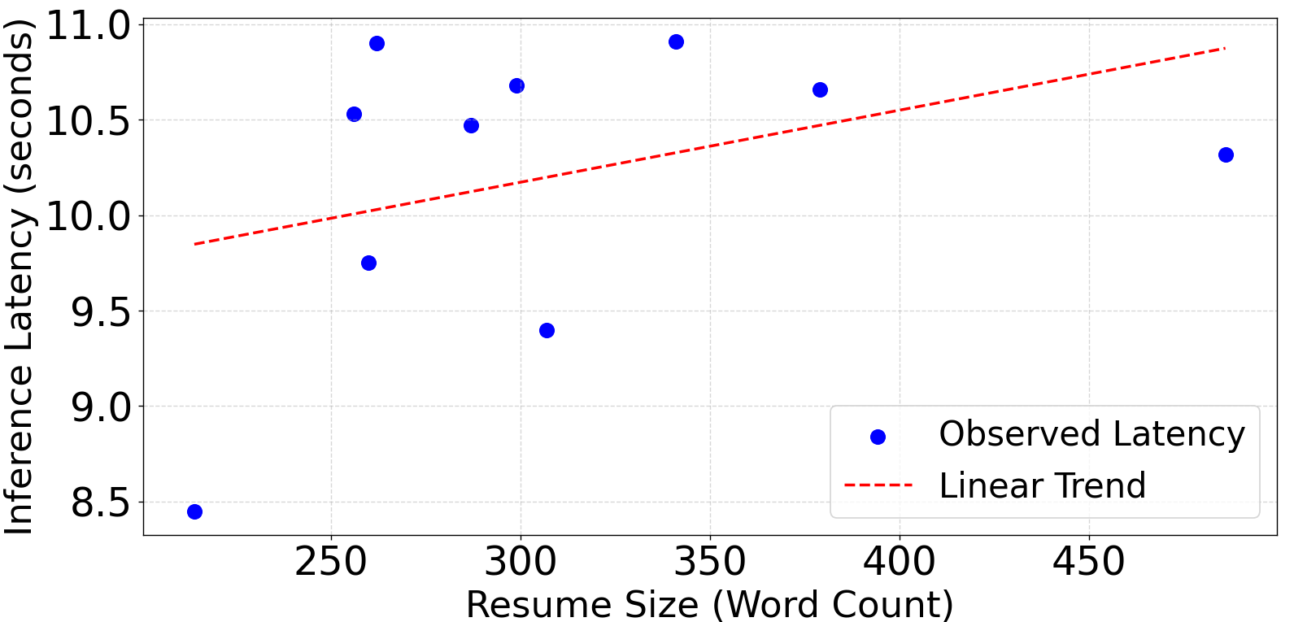Figure 8: Relation between resume word count and latency.

User Performance Improvement
LLM-RAG based model also use for training sessions for candidates. The users trained by model achieved a 20% improvement in their interview scores after completing multiple training sessions because they used the progress tracking system to identify their weaknesses and develop their ability to provide better answers. The process produced three main results which included better answer comprehension through complete response delivery and increased self-assurance and higher technical speaking abilities. The users demonstrated better interview results because of the structured method and feedback systems of program proved to be effective.

Conclusion
Fresh graduates often face challenges in preparing for interviews and providing relatable answers to interview questions. LLM provides better context aware answers and questions on all topics. LLM and RAG model combine to analyse candidate resume and extract relevant skill. RAG model provides context aware questions relevant to skills in resume. The answers from candidate assess for deep understanding of concept and facts. The models performance evaluate across five different interview session with candidates. A HR evaluated the questing and answer evaluation ability of combined LLM and RAG model. The result shows the model provided context aware questions related to skills mentioned in resume and was able to appropriately rate answers from candidate as validated by HR. Similarly, the candidate who underwent training with LLM-RAG model also showed increased performance in answering skill-based questions. The analysis show that proposed AI-powered interview simulator shows better performance than traditional systems because it delivers customized results while maintaining assessment accuracy and protecting user information. The platform proves itself as an effective intelligent interview training system through its ability to extract skills accurately and maintain assessment consistency while showing measurable user performance improvements.

References
- Q. Xinyue, Z. Yao, X. Xiang and Y. Wang, “An Interview System Based on Large Language Models and Multi-Agent Interactions,” in Proc. 2024 20th International Conference on Natural Computation, Fuzzy Systems and Knowledge Discovery (ICNC-FSKD), Guangzhou, China, Jul. 19–21, 2024, pp. 1–8, doi: 10.1109/ICNC-FSKD64080.2024.10702317.
- V. V. Satyanarayana Tallapragada, V. Sushma Raj, U. Deepak, P. Divya Sai and T. Mallikarjuna, “Improved Resume Parsing based on Contextual Meaning Extraction using BERT,” in Proc. 2023 7th International Conference on Intelligent Computing and Control Systems (ICICCS), 2023, pp. 1702–1708, doi: 10.1109/ICICCS56967.2023.10142800.
- A. D. Abisha, S. Keerthana, R. Navedha Evanjalin, K. Kavitha, J. M. S. Jothi and R. Ramya, “Resspar: AI-Driven Resume Parsing and Recruitment System using NLP and Generative AI,” in Proc. 2024 Second International Conference on Intelligent Cyber Physical Systems and Internet of Things (ICoICI), Coimbatore, India, Aug. 28–30, 2024, pp. 1–6, doi: 10.1109/ICOICI62503.2024.10696451
- C. N. Hang, C. W. Tan and P.-D. Yu, “MCQGen: A Large Language Model-Driven MCQ Generator for Personalized Learning,” IEEE Access, vol. 12, pp. 102261–102273, 2024, doi: 10.1109/ACCESS.2024.3420709.
- H. W. Awalurahman, R. F. Aji and I. Budi, “Transformer and Large Language Models for Automatic Multiple-Choice Question Generation: A Systematic Literature Review,” IEEE Access, vol. 13, pp. 127100-127112, Jul. 2025, doi: 10.1109/ACCESS.2025.3590423.
- H. N. Patel, A. Surti, P. Goel and B. Patel, “A Comparative Analysis of Large Language Models with Retrieval-Augmented Generation based Question Answering System,” in Proc. 2024 8th International Conference on I-SMAC (IoT in Social, Mobile, Analytics and Cloud), Tiruchirappalli, India, Oct. 10–12, 2024, pp. 1–6, doi: 10.1109/I-SMAC58731.2024.10714814.
- A. V. Chandak, H. Pandey, G. Rushiya and H. Sharma, “Resume Parser and Job Recommendation System using Machine Learning,” in Proc. 2024 International Conference on Emerging Systems and Intelligent Computing (ESIC), pp. 157–162, 2024, doi: 10.1109/ESIC60604.2024.10481635.
- Y. Gao, M. Yogatama, N. Khashabi and H. Haas, “Retrieval-Augmented Generation for Large Language Models: A Survey,” arXiv, Dec. 2023, doi: arXiv:2312.10997.
- W. Xie et al., “Grade Like a Human: Rethinking Automated Assessment with Large Language Models,” arXiv, pp. 1 -21, May 2024, doi: arXiv:2405.19694.
- Y. Chu et al., “A LLM-Powered Automatic Grading Framework with Human-Level Guidelines Optimization,” arXiv, Oct. 2024, updated Jun. 2025, doi: arXiv:2410.02165.
- C. Sharma et al., “Retrieval-Augmented Generation: A Comprehensive Survey of Architectures, Enhancements, and Robustness Frontiers,” arXiv, 2025, doi: arXiv:2506.00054.
- A. Singh et al., “Agentic Retrieval-Augmented Generation: A Survey on Agentic RAG,” arXiv, 2025, doi: arXiv:2501.09136.
- B. Peng et al., “Graph Retrieval-Augmented Generation: A Survey,” arXiv, Aug. 2024, doi: arXiv:2408.08921.
- R. Gao, H. E. Merzdorf, S. Anwar, M. C. Hipwell and A. R. Srinivasa, “Automatic assessment of text-based responses in post-secondary education: A systematic review,” Computers and Education: Artificial Intelligence, vol. 6, Art. no. 100206, Jun. 2024, doi: 10.1016/j.caeai.2024.100206.
- S. Maity, A. Deroy and S. Sarkar, “Can large language models meet the challenge of generating school-level questions?,” Computers and Education: Artificial Intelligence, vol. 8, Art. no. 100370, Jun. 2025, doi: 10.1016/j.caeai.2025.100370.

